Overall AI Application Flow
Think of the technologies like this:
LLM → Prompt Engineering → Embeddings → Vector Database → RAG → LangChain → LangGraph → Spring AI → AI Agents
However, technically these are different layers, so they don't always execute strictly in this sequence.
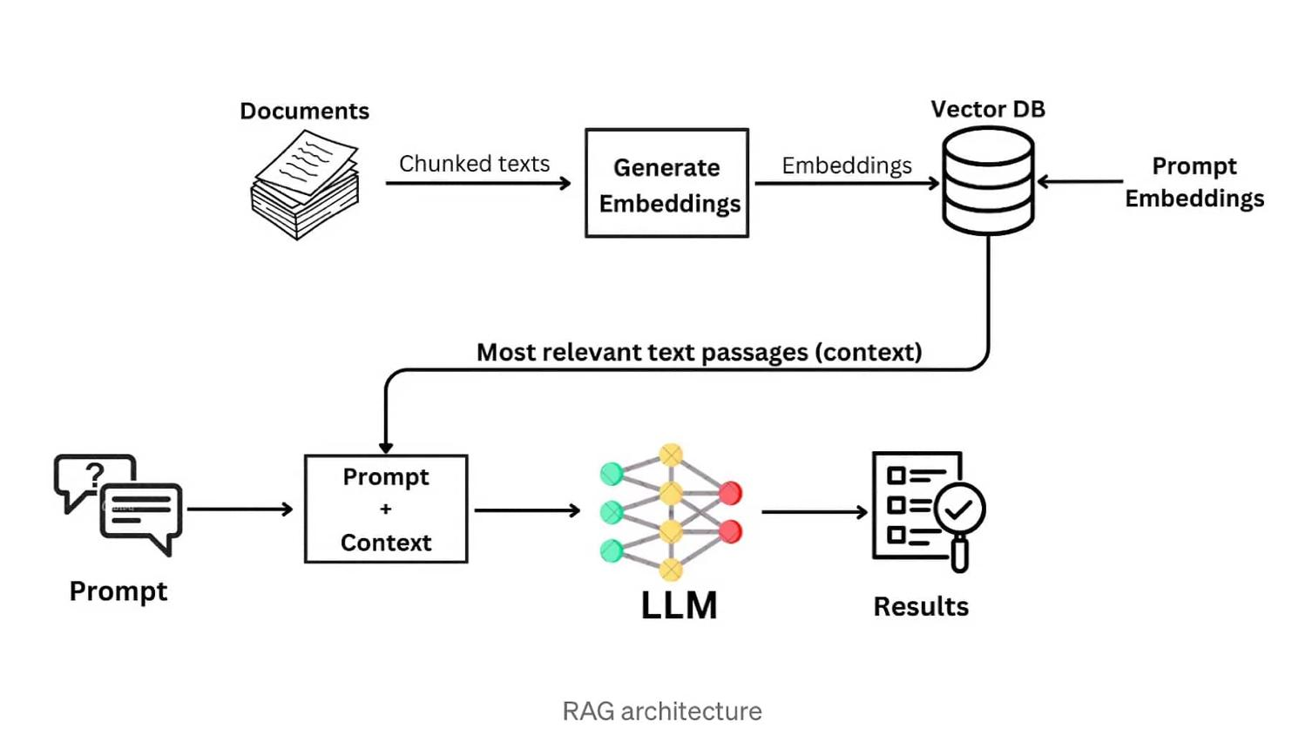
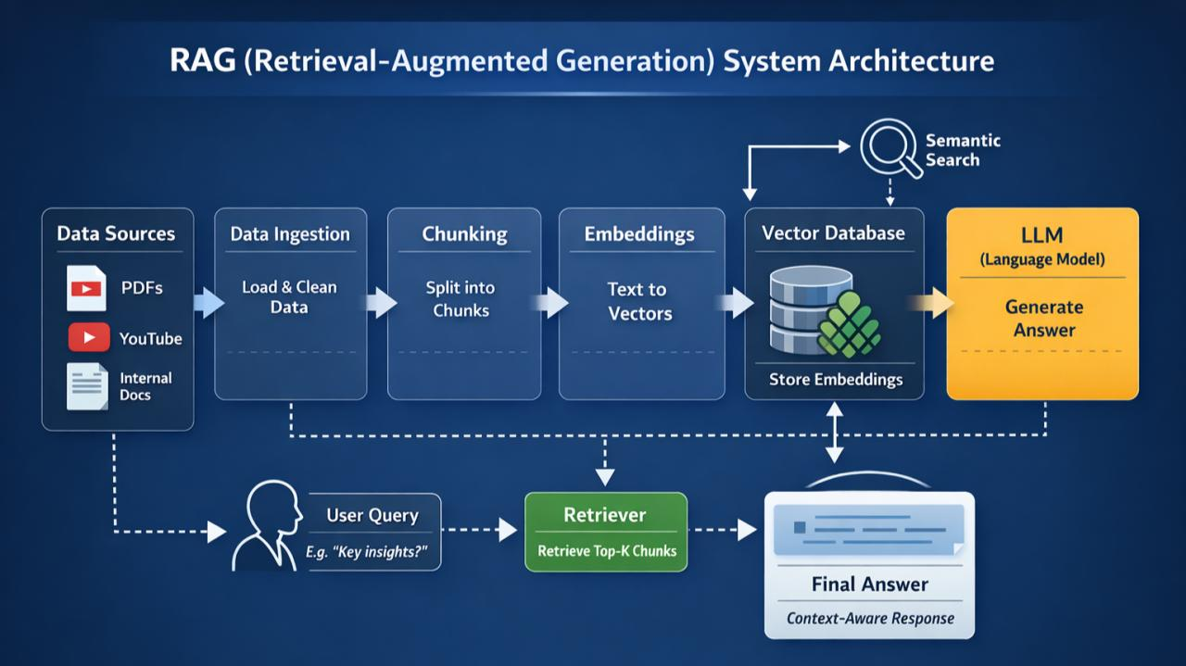
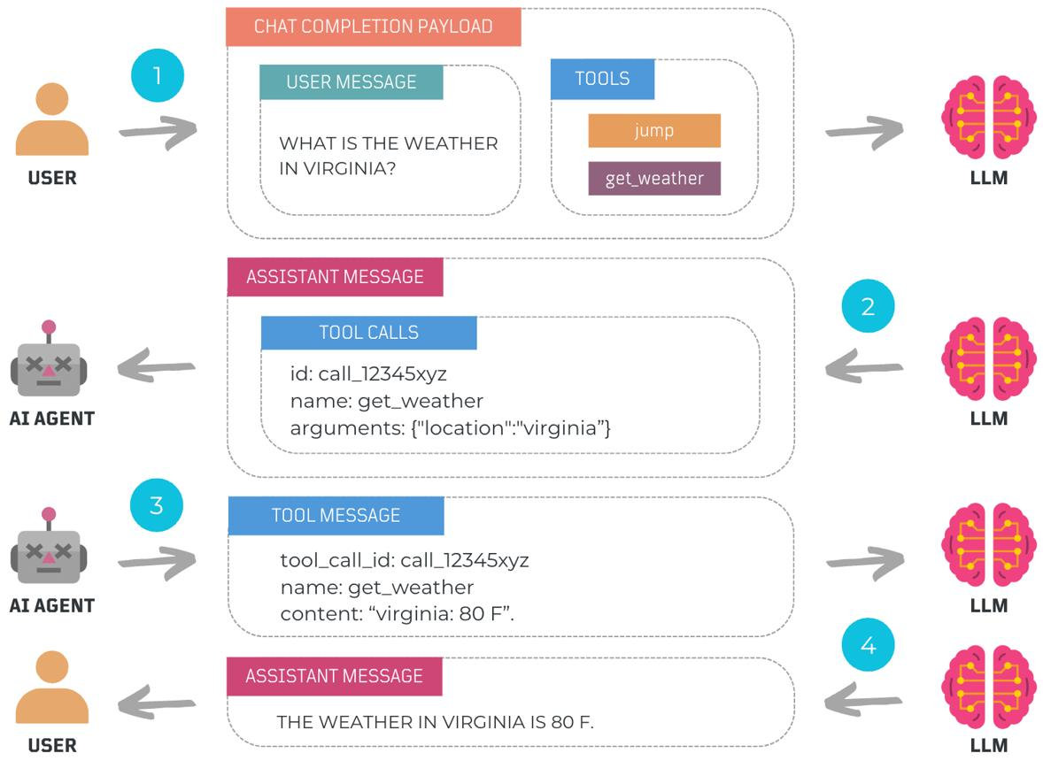
6

1. LLM — Large Language Model
An LLM is the brain that understands and generates human language.
Examples
include models from OpenAI, Anthropic, Google, Meta, and others.
What does an LLM do?
You give it:
Input → LLM → Output
For example:
User:
Explain Spring Boot in simple terms.

↓

LLM

↓

Spring Boot is a framework built on Spring
that simplifies Java application development...
An LLM can perform:
- Text generation
- Question answering
- Summarization
- Translation
- Code generation
- Classification
- Reasoning
- Information extraction
Important LLM concepts
As a trainer, you should know:
Model → Tokens → Context Window → Prompt → Parameters → Temperature → Top-P → Output
For example:
"Explain Java Streams"
↓
Tokens
↓
Context
↓
Prompt
↓
LLM
↓
Response
Interview answer
"An LLM is a large neural-network-based language model trained on large amounts of text data to understand and generate human-like language. Applications interact with LLMs through prompts and APIs."

2. Prompt Engineering
Once you have an LLM, the next question is:
How do I communicate effectively with the model?
That's where Prompt Engineering comes in.
A prompt is the instruction/context given to the LLM.
Simple prompt
Explain Java.
Better prompt:
You are a Java trainer.

Explain Java Streams to a beginner.

Include:
1. Definition
2. Why Streams are used
3. Important methods
4. Code example
5. Interview questions
The second prompt gives the model:
- Role
- Task
- Context
- Expected output
- Format
Common prompt techniques
You should know:
- Zero-shot prompting
- Few-shot prompting
- Role prompting
- Chain-of-thought-style reasoning requests
- Structured prompting
- Output constraints
- Prompt templates
- System prompts
- User prompts
Enterprise example
Suppose you're building an employee assistant.
System:
You are an HR assistant.

User:
Explain the leave policy for an employee.
The system prompt establishes the behavior.

3. Embeddings
Now we reach an important concept for RAG.
An embedding converts text into a vector of numbers representing its semantic meaning.
For example:
"Java is a programming language"
↓
Embedding Model
↓
[0.21, -0.45, 0.87, 0.13, ...]
The vector may contain hundreds or thousands of dimensions.
The important idea is:
Similar meanings produce vectors that are close to each other in vector space.
For example:
"How do I learn Java?"
↓
Vector A

"Java learning roadmap"
↓
Vector B

"How to cook pasta?"
↓
Vector C
Vector A and B should be semantically closer than A and C.
Why do we need embeddings?
Because computers don't naturally perform semantic similarity searches on plain text.
Embeddings allow us to perform:
Semantic Search
rather than just:
Keyword Search

4. Vector Database
Once we generate embeddings, we need somewhere to store them.
That's where a Vector Database comes in.
Examples include:
- Pinecone
- Milvus
- Weaviate
- Chroma
- FAISS
- pgvector
- Elasticsearch/OpenSearch vector capabilities
Conceptually:
Document
↓
Chunking
↓
Embedding Model
↓
Vector
↓
Vector Database
A vector database typically stores:
Vector
+
Original text/chunk
+
Metadata
For example:
ID: 101

Text:
"Employees can apply for 20 days of annual leave."

Vector:
[0.21, -0.34, 0.76, ...]

Metadata:
{
"document": "HRPolicy.pdf",
"page": 12
}
Then a user asks:
"How many annual leave days can I take?"
The query is converted into an embedding and compared with stored vectors.

5. RAG — Retrieval-Augmented Generation
This is one of the most important enterprise AI concepts.
RAG means:
Retrieve relevant information first, then give that information to the LLM to generate the answer.
Why do we need RAG?
Because an LLM may not know your organization's:
- HR policies
- Product documentation
- Internal projects
- Customer information
- Company procedures
- Latest documents
We don't necessarily want to retrain the LLM every time company information changes.
Instead:
Company Documents
↓
Chunking
↓
Embeddings
↓
Vector Database
Then:
User Question
↓
Embedding
↓
Vector Similarity Search
↓
Relevant Documents
↓
Prompt
↓
LLM
↓
Answer
Example
Suppose you upload:
Employee_Handbook.pdf
User asks:
"How many sick leaves can an employee take?"
RAG retrieves the relevant section of the PDF and sends it to the LLM.
The LLM generates:
"According to the employee handbook, employees are entitled to..."
RAG architecture
DOCUMENTS
↓
Chunking
↓
Embeddings
↓
Vector Database
↑
|
User Question → Embedding
↓
Similarity Search
↓
Relevant Context
↓
Prompt
↓
LLM
↓
Answer
This is extremely useful for enterprise Java applications.

6. LangChain
Now we move from AI concepts into AI application frameworks.
LangChain is a framework/ecosystem for building applications powered by LLMs.
Instead of manually writing all the integration code, LangChain provides abstractions for things like:
- LLM interaction
- Prompt templates
- Output parsing
- Embeddings
- Vector stores
- Retrievers
- RAG
- Tools
- Agents
- Conversation workflows
Conceptually:
Application
↓
LangChain
↓
LLM / Embeddings / Vector DB / Tools
For example:
User Question
↓
PromptTemplate
↓
Retriever
↓
Vector Database
↓
Context
↓
LLM
↓
Answer
Why use LangChain?
Without a framework, you might have to manually manage:
API calls
Prompt construction
Document processing
Embedding calls
Vector search
Context management
Output parsing
Tool integration
A framework gives you reusable abstractions.

7. LangGraph
LangChain is useful for building LLM applications.
LangGraph is focused on building stateful, multi-step, controllable AI workflows/agents.
Think:
LangChain
Question
↓
Retrieve
↓
LLM
↓
Answer
LangGraph
┌──────────────┐
↓ │
User → Agent → Tool → Result
↓
Decide
↓
Another Tool
↓
Answer
LangGraph is useful when an AI application needs:
- Multiple steps
- State
- Conditional routing
- Loops
- Human approval
- Multiple agents
- Tool calling
- Long-running workflows
For example:
Customer Question
↓
Agent
↓
Is database information needed?
/ \
Yes No
↓ ↓
Database LLM
↓ ↓
└────→ Final Answer
That is where graph-based orchestration becomes valuable.

8. Spring AI
For you as a Java Full Stack trainer, this is particularly important.
Spring AI brings AI application-development abstractions into the Spring ecosystem.
It allows Java developers to build AI applications using familiar Spring concepts.
Conceptually:
React
↓
Spring Boot REST API
↓
Spring AI
↓
LLM
Spring AI supports concepts such as:
- Chat models
- ChatClient
- Prompt templates
- Structured output
- Embeddings
- Vector stores
- RAG
- Tool calling
- AI model integration
Example architecture
React UI
↓
Spring Boot
↓
ChatClient
↓
LLM
↓
Response
For RAG:
React
↓
Spring Boot
↓
Spring AI
↓
Retriever
↓
Vector Store
↓
Relevant Context
↓
LLM
↓
Answer
This is an excellent area for you because you can position yourself as:
Java Full Stack + Spring Boot + Generative AI trainer
rather than only as a traditional Java trainer.

9. AI Agents
Now we come to the more advanced concept.
A normal LLM generally does:
Question → LLM → Answer
An AI Agent can:
Understand goal
↓
Plan
↓
Choose a tool
↓
Execute tool
↓
Observe result
↓
Reason
↓
Choose next action
↓
Final Answer
Example
User:
"Find the sales of the company for last month and prepare a summary."
An agent could decide:
User Request
↓
Agent
↓
Need sales data?
↓
Database Tool
↓
Sales Data
↓
Analyze Data
↓
Generate Summary
↓
Return Answer
The important concept is tool calling.
Tools might include:
Database
REST API
Web Search
Calculator
Email
CRM
File System
Internal Enterprise APIs

How everything connects
Now put all the concepts together.
Level 1 — LLM
User → LLM → Answer
Level 2 — Prompt Engineering
User
↓
Well-designed Prompt
↓
LLM
↓
Better Answer
Level 3 — Embeddings
Text
↓
Embedding Model
↓
Vector
Level 4 — Vector Database
Documents
↓
Embeddings
↓
Vector DB
Level 5 — RAG
Question
↓
Vector Search
↓
Relevant Documents
↓
LLM
↓
Grounded Answer
Level 6 — LangChain / Spring AI
Frameworks help you build these applications more easily.
Application
↓
LangChain / Spring AI
↓
LLM + Embeddings + Vector DB + Tools
Level 7 — LangGraph
For complex workflows:
Agent
↓
Decision
↓
Tool
↓
Result
↓
Decision
↓
Tool
↓
Final Answer
Level 8 — AI Agents
The application becomes capable of reasoning about a goal, selecting tools, performing actions, and completing multi-step tasks.

A very good interview explanation
If an interviewer asks:
"Can you explain your Generative AI knowledge?"
You can say:
Generative AI Interview Answer
My understanding of Generative AI starts with LLMs, which are the core models responsible for understanding and generating natural language.
I use Prompt Engineering to design effective system and user instructions and control the behavior and output of the model.
For enterprise applications, I work with embeddings, where documents and queries are converted into vectors so that we can perform semantic similarity searches. These vectors can be stored in vector databases.
On top of that, we can implement RAG, or Retrieval-Augmented Generation, where relevant information is retrieved from enterprise documents or knowledge bases and provided as context to the LLM before generating the response. This helps the application answer questions based on organization-specific data.
For application development, frameworks such as LangChain provide abstractions for prompts, models, embeddings, retrievers, vector stores, tools, and agents. LangGraph can be used when we need stateful, multi-step, conditional, or agentic workflows.
Since my primary background is Java and Spring Boot, I am particularly interested in Spring AI. It allows Java developers to integrate LLMs, ChatClient, prompt templates, structured output, embeddings, vector stores, RAG, and tool calling into Spring Boot applications.
At the advanced level, I work with AI Agents and agentic workflows, where the AI can understand a goal, decide what actions are required, invoke tools such as APIs or databases, evaluate the results, and continue the workflow until the task is completed.
So I see the overall progression as:
LLMs → Prompt Engineering → Embeddings → Vector Databases → RAG → AI Frameworks → Tool Calling → Agentic Workflows.
My focus is on applying these concepts to real-world enterprise applications using Java, Spring Boot, React, databases, and cloud technologies.
The easiest way to remember it
LLM = Brain
Prompt Engineering = Instructions
Embeddings = Meaning represented as vectors
Vector DB = Memory/search system
RAG = Give the LLM relevant external knowledge
LangChain = AI application building blocks
LangGraph = Complex AI workflow orchestration
Spring AI = AI development for the Spring/Java ecosystem
Agents = AI that can decide and take actions using tools
This is a very strong conceptual sequence for you to use in corporate training and senior-level trainer interviews.

Yes. A very good real-time, interview-ready Python project for your profile is an:
Enterprise Document Q&A / Knowledge Assistant
We'll build a practical Python + LangChain + Vector DB + RAG + LLM application where a user uploads company PDFs and asks questions about them.
For example, upload:
- Employee Handbook
- HR Policy
- Project Documentation
- Java/Spring documentation
- Training material
- Product manuals
Then ask:
"How many days of annual leave are allowed?"
The system retrieves the relevant document sections and generates an answer based on that content.

1. Project Architecture
┌──────────────────────┐
│ User / UI │
│ Streamlit / React │
└──────────┬───────────┘
│
│ Question
▼
┌──────────────────────┐
│ Python Backend │
│ LangChain │
└──────────┬───────────┘
│
▼
Create Embedding
│
▼
┌──────────────────────┐
│ Vector Database │
│ FAISS │
└──────────┬───────────┘
│
Similarity Search
│
▼
┌──────────────────────┐
│ Relevant Documents │
│ / Chunks │
└──────────┬───────────┘
│
▼
┌──────────────────────┐
│ RAG Prompt │
│ Context + Question │
└──────────┬───────────┘
│
▼
┌──────────────────────┐
│ LLM │
│ OpenAI / Ollama │
└──────────┬───────────┘
│
▼
┌──────────────────────┐
│ Answer │
└──────────────────────┘

2. Technologies
We'll use:
Layer | Technology
Language | Python
AI Framework | LangChain
LLM | OpenAI / Ollama
Embeddings | OpenAI Embeddings / HuggingFace
Vector DB | FAISS
RAG | LangChain
PDF Processing | PyPDF
UI | Streamlit
Environment | Python venv
Optional production DB | PostgreSQL + pgvector
This is a very good project because you can later explain the same architecture using Spring AI + Spring Boot.

3. Project Structure
Create:
enterprise-rag-assistant/
│
├── app.py
├── config.py
├── requirements.txt
├── .env
│
├── data/
│ └── documents/
│ ├── employee_handbook.pdf
│ ├── hr_policy.pdf
│ └── company_policy.pdf
│
├── vectorstore/
│
├── services/
│ ├── document_loader.py
│ ├── embedding_service.py
│ ├── vector_service.py
│ └── rag_service.py
│
└── prompts/
└── rag_prompt.py
This structure is much better for training than putting everything into one Python file.

4. Step 1 — Install Python Packages
Create a virtual environment:
python -m venv venv
Activate it on Windows:
venv\Scripts\activate
Install:
pip install langchain
pip install langchain-openai
pip install langchain-community
pip install faiss-cpu
pip install pypdf
pip install python-dotenv
pip install streamlit
Or:
pip install -r requirements.txt
requirements.txt:
langchain
langchain-openai
langchain-community
faiss-cpu
pypdf
python-dotenv
streamlit

5. Step 2 — Configure API Key
Create:
.env
For example:
OPENAI_API_KEY=your-api-key
Never hard-code your API key into Python source code.

6. Step 3 — Load PDF Documents
Create:
services/document_loader.py
from langchain_community.document_loaders import PyPDFDirectoryLoader

def load_documents():

loader = PyPDFDirectoryLoader(
"data/documents"
)

documents = loader.load()

print(f"Loaded {len(documents)} pages")

return documents
Now all PDFs under:
data/documents/
are loaded.

7. Step 4 — Document Chunking
A large PDF shouldn't be sent directly to an LLM.
We divide it into smaller chunks.
PDF
↓
Pages
↓
Chunks
↓
Embeddings
Create:
services/vector_service.py
from langchain_text_splitters import RecursiveCharacterTextSplitter

def split_documents(documents):

splitter = RecursiveCharacterTextSplitter(
chunk_size=1000,
chunk_overlap=200
)

chunks = splitter.split_documents(documents)

print(f"Created {len(chunks)} chunks")

return chunks
Why chunking?
Suppose your document has:
500 pages
You don't want:
500 pages → LLM
Instead:
500 pages
↓
Small meaningful chunks
↓
Embeddings
↓
Vector DB

8. Step 5 — Create Embeddings
Now convert each chunk into a vector.
from langchain_openai import OpenAIEmbeddings

def create_embeddings():

embeddings = OpenAIEmbeddings(
model="text-embedding-3-small"
)

return embeddings
Conceptually:
"Employees receive 20 days annual leave"

↓

Embedding Model

↓

[0.023, -0.451, 0.821, ...]

9. Step 6 — Store Embeddings in FAISS
FAISS is a vector similarity-search library.
from langchain_community.vectorstores import FAISS

def create_vector_store(chunks, embeddings):

vector_store = FAISS.from_documents(
chunks,
embeddings
)

vector_store.save_local(
"vectorstore"
)

return vector_store
Now we have:
Documents
↓
Chunks
↓
Embeddings
↓
FAISS

10. Step 7 — Create Retriever
Now we need to retrieve relevant documents.
retriever = vector_store.as_retriever(
search_kwargs={
"k": 4
}
)
k=4 means:
Retrieve the four most relevant chunks.
For example:
Question:

"What is the annual leave policy?"

↓

Embedding

↓

Vector Search

↓

Chunk 23
Chunk 47
Chunk 51
Chunk 78

11. Step 8 — Create RAG Prompt
Create:
prompts/rag_prompt.py
from langchain_core.prompts import ChatPromptTemplate

RAG_PROMPT = ChatPromptTemplate.from_template("""
You are an enterprise knowledge assistant.

Answer the user's question using ONLY the
provided context.

If the answer is not available in the context,
say:

"I don't have enough information in the
provided documents."

Context:
{context}

Question:
{question}

Answer:
""")
This is important.
We're telling the LLM:
Don't invent an answer. Use the retrieved context.
This helps reduce hallucination.

12. Step 9 — Connect LLM
from langchain_openai import ChatOpenAI

llm = ChatOpenAI(
model="gpt-4.1-mini",
temperature=0
)
For a knowledge assistant, a low temperature is often appropriate because we want consistent answers.

13. Step 10 — Build RAG Chain
Now combine:
Retriever
+
Prompt
+
LLM
Example:
from langchain_core.output_parsers import StrOutputParser

def create_rag_chain(llm, retriever):

chain = (
{
"context": retriever,
"question": lambda x: x
}
| RAG_PROMPT
| llm
| StrOutputParser()
)

return chain
The conceptual flow is:
Question
↓
Retriever
↓
Relevant Chunks
↓
Prompt
↓
LLM
↓
Answer

14. Complete RAG Service
services/rag_service.py
from langchain_openai import ChatOpenAI
from langchain_openai import OpenAIEmbeddings
from langchain_community.vectorstores import FAISS

from prompts.rag_prompt import RAG_PROMPT

class RAGService:

def __init__(self):

self.embeddings = OpenAIEmbeddings(
model="text-embedding-3-small"
)

self.vector_store = FAISS.load_local(
"vectorstore",
self.embeddings,
allow_dangerous_deserialization=True
)

self.retriever = self.vector_store.as_retriever(
search_kwargs={
"k": 4
}
)

self.llm = ChatOpenAI(
model="gpt-4.1-mini",
temperature=0
)

def ask(self, question):

documents = self.retriever.invoke(question)

context = "\n\n".join(
document.page_content
for document in documents
)

prompt = RAG_PROMPT.format(
context=context,
question=question
)

response = self.llm.invoke(prompt)

return response.content

15. Step 11 — Create Streamlit UI
app.py
import streamlit as st

from services.rag_service import RAGService

st.set_page_config(
page_title="Enterprise Knowledge Assistant"
)

st.title("Enterprise Knowledge Assistant")

st.write(
"Ask questions about your uploaded company documents."
)

@st.cache_resource
def get_rag_service():

return RAGService()

rag_service = get_rag_service()

question = st.text_input(
"Enter your question:"
)

if question:

with st.spinner("Searching documents..."):

answer = rag_service.ask(question)

st.subheader("Answer")

st.write(answer)
Run:
streamlit run app.py

16. What happens at runtime?
Suppose you ask:
"How many annual leave days are employees entitled to?"
The application performs:
USER
│
▼
"How many annual leave days?"
│
▼
Embedding
│
▼
Vector Search
│
▼
┌─────────────────────┐
│ Relevant PDF chunks │
└──────────┬──────────┘
│
▼
RAG Prompt
│
▼
LLM
│
▼
Final Answer
Example:
According to the Employee Handbook,
employees are entitled to 20 days of
annual leave per calendar year.

17. The Most Important Concept: RAG
For your interview, explain RAG in these 5 steps:
Step 1 — Load
PDF → Documents
Step 2 — Split
Documents → Chunks
Step 3 — Embed
Chunks → Vectors
Step 4 — Retrieve
Question → Similar Chunks
Step 5 — Generate
Question + Retrieved Context → LLM → Answer
Remember:
RAG = Retrieval + Augmentation + Generation

18. Real-Time Enterprise Use Case
You can make this project much more impressive by converting it into:
Corporate Employee Knowledge Assistant
Documents:
HR Policy
Leave Policy
Travel Policy
Insurance Policy
Employee Handbook
Work From Home Policy
IT Security Policy
Employee asks:
"Can I work from home for three consecutive days?"
The system searches the company documents and answers based on the policies.
Another question:
"What is the reimbursement limit for business travel?"
Again:
Question
↓
Embedding
↓
Vector DB
↓
Relevant Policy
↓
RAG
↓
LLM
↓
Answer

19. Add Source/Citation Information
For a production-quality RAG application, don't return only the answer.
Return:
Answer
+
Source Document
+
Page Number
+
Relevant Chunk
For example:
Answer:

Employees are entitled to 20 days of annual leave.

Sources:

Employee_Handbook.pdf
Page: 14
This makes the application much more trustworthy.

20. Upgrade the Project
Once the basic project works, build these versions:
Version 1
PDF
↓
FAISS
↓
RAG
↓
LLM
Version 2
Add:
Multiple PDFs
Metadata
Source citations
Chat history
Version 3
Add:
React UI
↓
FastAPI
↓
LangChain
↓
Vector DB
↓
LLM
Version 4
Use a production vector database:
React
↓
FastAPI
↓
LangChain
↓
PostgreSQL + pgvector
↓
LLM
Version 5
Add:
Authentication
Role-based access
Document management
Conversation history
Feedback
Logging
Evaluation
Then you have something much closer to an enterprise GenAI application.

21. How this maps to your Java expertise
This is particularly valuable for you because you can build the same application in two stacks:
Python AI Stack
React
↓
FastAPI
↓
LangChain
↓
Vector DB
↓
LLM
Java AI Stack
React
↓
Spring Boot
↓
Spring AI
↓
Vector DB
↓
LLM
So your positioning becomes:
"I can build enterprise GenAI applications using both Python/LangChain and Java/Spring AI."
That is a much stronger profile than simply saying "I know Prompt Engineering and RAG."

Your project explanation in an interview
You can say:
RAG Project Interview Explanation
I recently worked on an Enterprise Document Knowledge Assistant using Python, LangChain, embeddings, FAISS vector database, and RAG.
The objective was to allow users to ask questions against enterprise documents such as HR policies, employee handbooks, and technical documentation.
First, I load PDF documents and split them into smaller chunks using a text splitter. Each chunk is converted into an embedding using an embedding model and stored in a FAISS vector database.
When a user asks a question, the question is also converted into an embedding. The application performs similarity search against the vector database and retrieves the most relevant document chunks.
These retrieved chunks are then added to a prompt along with the user's question. The prompt is sent to the LLM, which generates the final answer based on the retrieved context.
This is the RAG approach, where retrieval provides enterprise-specific knowledge to the LLM without requiring us to retrain the model.
I also designed the application in separate layers for document processing, embeddings, vector search, and RAG orchestration. The next improvements would include source citations, conversation memory, authentication, metadata filtering, and moving from FAISS to a production vector database such as PostgreSQL with pgvector.
For your learning path, I would build this project in stages rather than jumping directly to agents: Python basics → LangChain LLM → PromptTemplate → PDF → Chunking → Embeddings → FAISS → Retriever → RAG → Chat History → FastAPI → React → PostgreSQL/pgvector → Agents. This will give you both the conceptual depth and the hands-on project story needed for a senior corporate trainer interview.

